Dr. Shubhangi Kharche

**AWS Project 2**

**Architecture diagram**

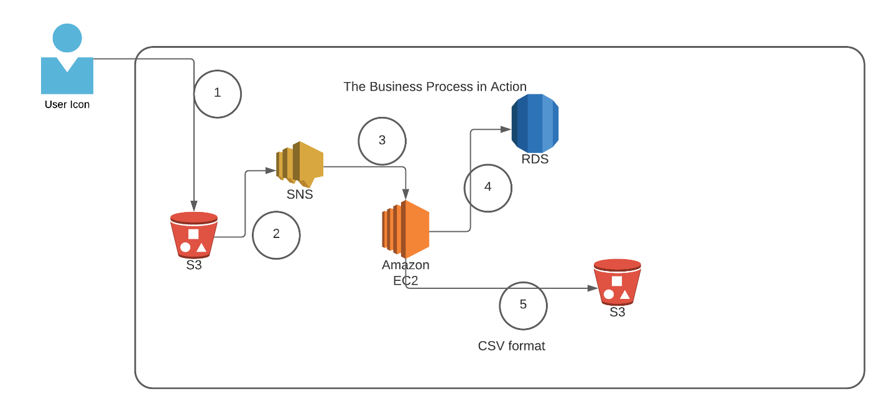

|  |  |
| --- | --- |
| **Architecture Implementation** | |
| 1 | The customer uploads the invoice data to S3 bucket in a text format as per their guidelines and policies. This bucket will have a policy to auto delete any content that is more than 1 day old (24 hours). |
| 2 | An event will trigger in the bucket that will place a message in SNS topic |
| 3 | A custom program running in EC2 will subscribe to the SNS topic and get the message placed by S3 event |
| 4 | The program will use S3 API to read from the bucket, parse the content of the file and create a CSV record and save the details in an RDS database |
| 5 | The program will use S3 API to write CSV record to destination S3 bucket as new S3 object. |

**Skills: Amazon S3, Amazon EC2, Amazon RDS, Amazon SNS, API, Python, Boto3**

**Step 1: SNS and S3 topic creation**

|  |  |
| --- | --- |
| Step number | a |
| Step name | Creation of Source and target buckets |
| Instructions | 1) Navigate to S3 using the Services button at the top of the screen  2) Select "Create Bucket"  3) Enter a source bucket name and use the default options for the rest of the fields  4) Click on "Create Bucket'  5) Repeat the above steps to create a target bucket |
| Expected screenshots | 1) Screen showing created S3 source and target buckets |

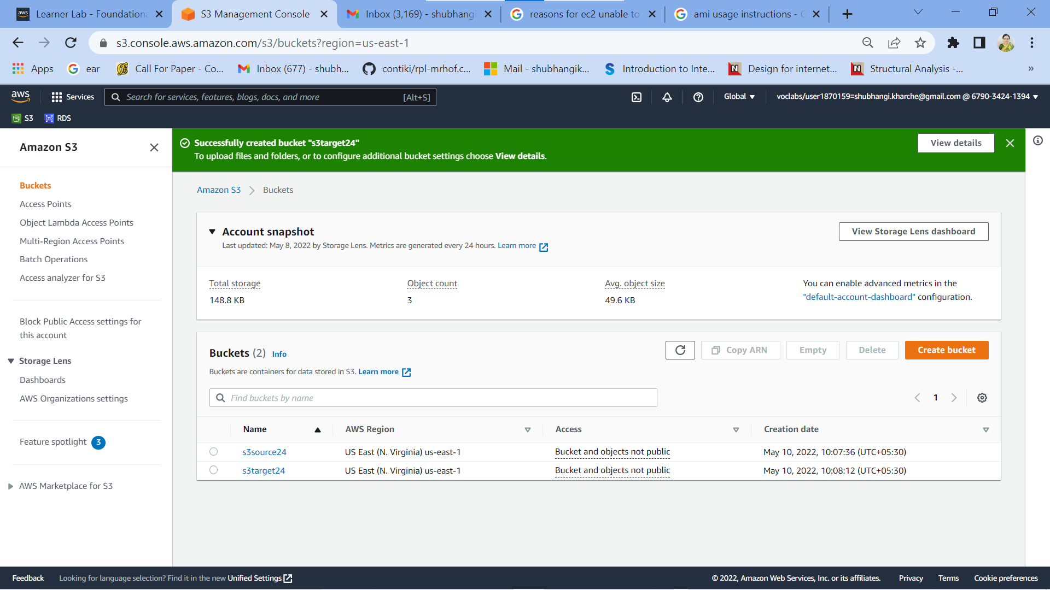

**Fig1: Screen showing created S3 source and target buckets**

|  |  |  |
| --- | --- | --- |
| Step number | b |  |
| Step name | Creation of SNS subscription |  |
| Instructions | 1) Navigate to SNS -> Topics  2) Click on "Create Topic"  3) Enter the following fields  Name : S3toEC2Topic  The other options can be ignored for now  4) Click on Create Topic |  |
| Expected screenshots | 1) Creation of SNS topic |  |

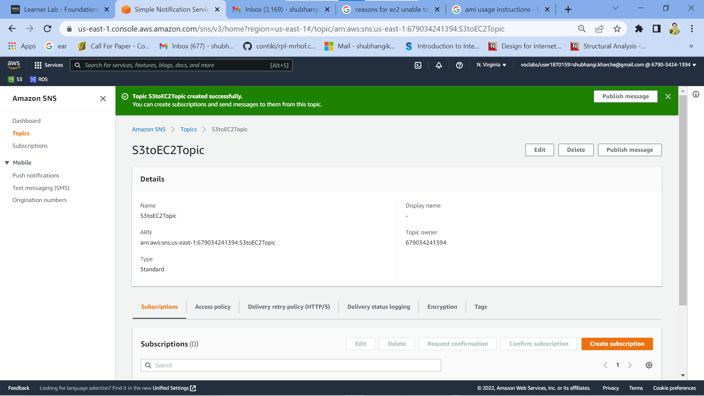

**Fig 2: Creation of SNS topic**

|  |  |
| --- | --- |
| Step number | c |
| Step name | Modification of SNS Access Policy |
| Instructions | 1) Navigate to SNS -> Topics and select the topic created in the previous step  2) Note down the ARN shown in the topic details  2) Click on Edit and select "Access Policy".  3) Replace the text in the JSON editor with the following  {  "Version": "2012-10-17",  "Id": "example-ID",  "Statement": [  {  "Sid": "example-statement-ID",  "Effect": "Allow",  "Principal": {  "AWS":"*"  },  "Action": [  "SNS:Publish"  ],  "Resource": "**SNS-topic-ARN**",  "Condition": {  "ArnLike": { "aws:SourceArn": "arn:aws:s3:*:*:**bucket-name**" },  "StringEquals": { "aws:SourceAccount": "**bucket-owner-account-id**" }  }  }  ]  }  4) Replace the bold text with the SNS topic ARN, source bucket name and your AWS account ID respectively.  5) Click on Save Changes |
| Expected screenshots | 1) JSON Editor screen |

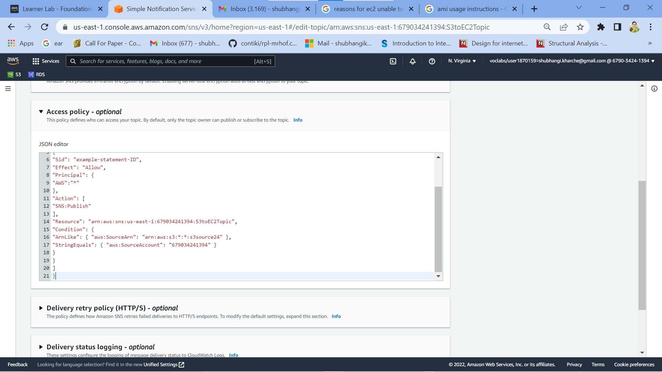

**Fig 3: JSON Editor screen**

|  |  |
| --- | --- |
| Step number | d |
| Step name | Configuring SNS notifications for S3 |
| Instructions | 1) Navigate to S3 and select the source bucket created in Step 1 (a)  2) Select Properties and scroll down to Event Notifications and select it  3) Select "Create Event Notification"  4) Fillup the details as follows  Name : S3PutEvent  Select PUT from the list of radio buttons  Destination : Select SNS Topic  SNS : Select S3ToEC2Topic  5) Save Changes |
| Expected screenshots | 1) Event Configuration Screen |

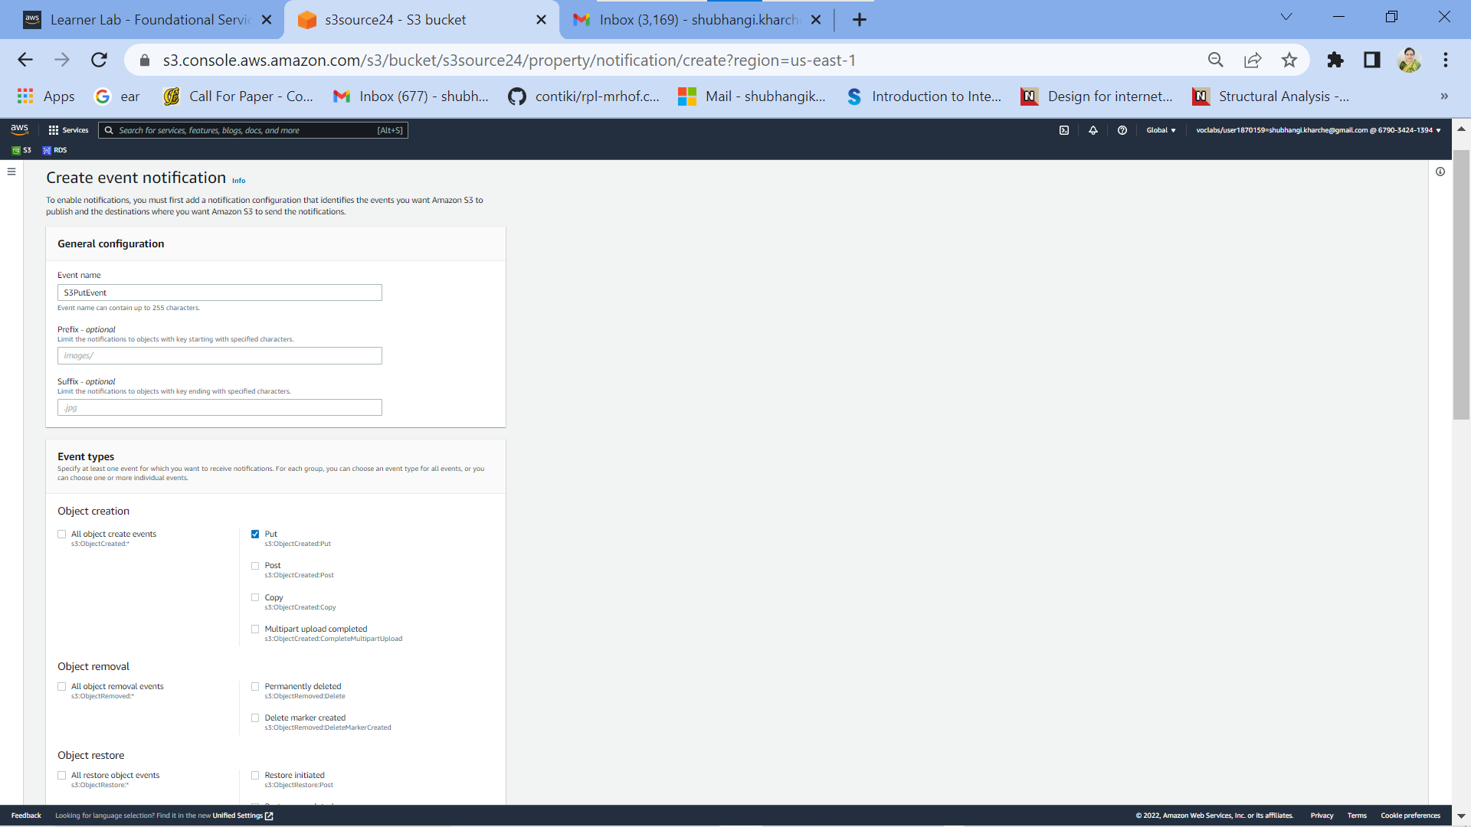

**Fig 4 (a): Event Configuration Screen-1**

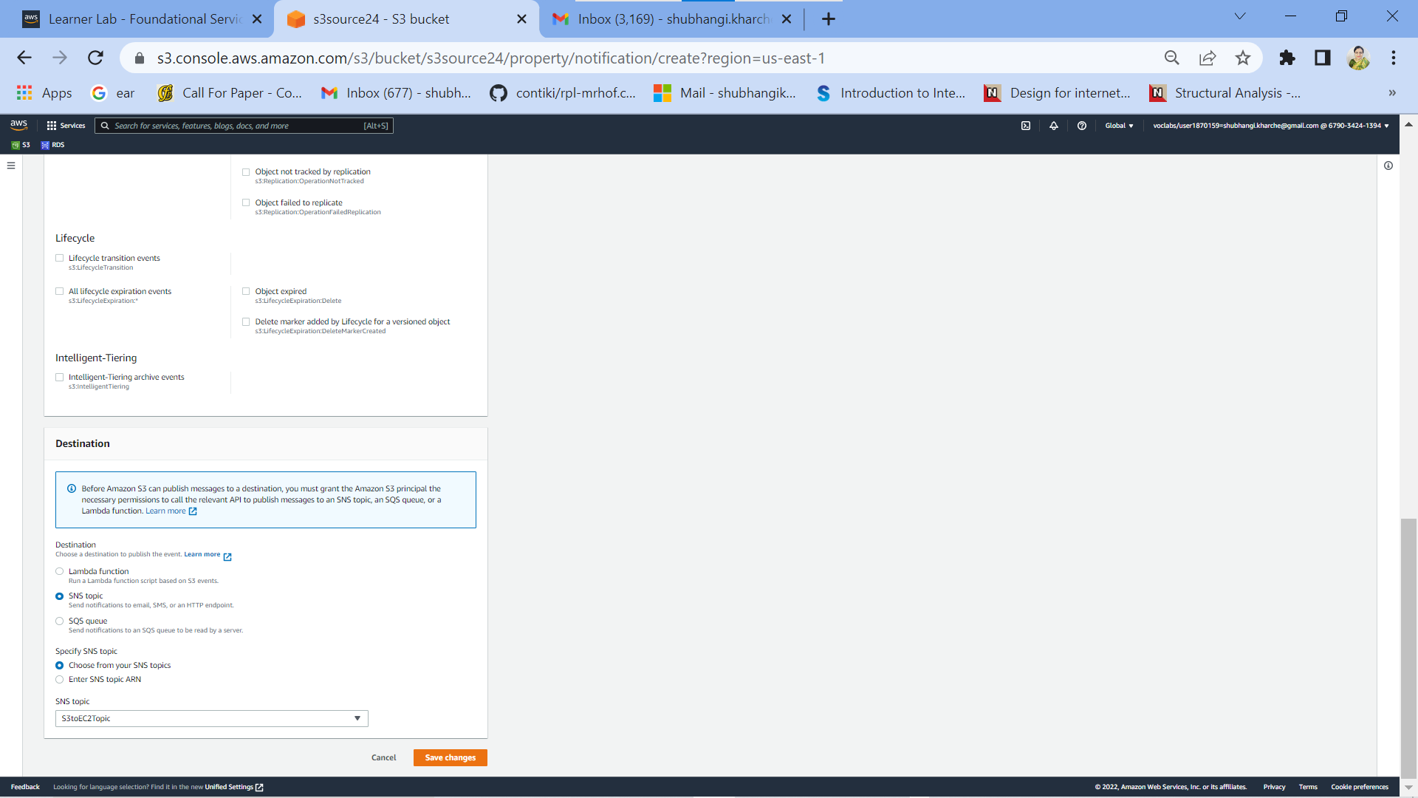

**Fig 4 (b): Event Configuration Screen-2**

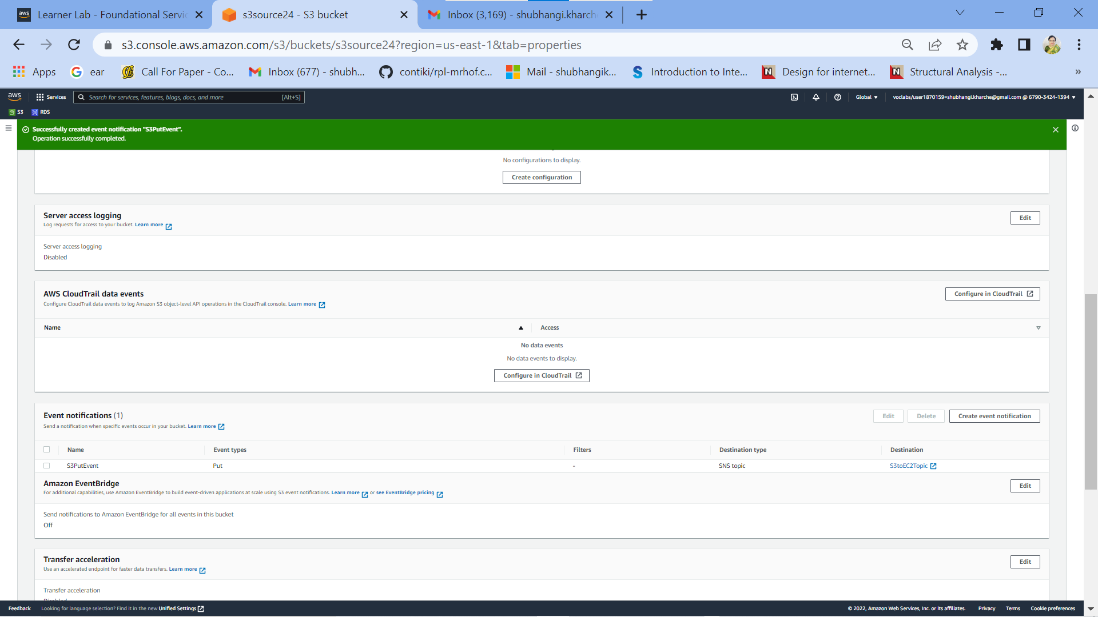

**Fig 4 (c): Event Configuration details Screen-3**

Step 2: Run the custom program in the EC2 instance

|  |  |  |
| --- | --- | --- |
| Step number | a |  |
| Step name | Creation of the EC2 instance and RDS instance |  |
| Instructions | 1) Navigate to EC2 -> Instances  2) Create an EC2 instance with the following parameters  AMI : Amazon Linux 2  VPC : Default  Security group : Ports 22 and 8080 should be opened  3) Navigate to RDS  4) Create an RDS instance with the following parameters:  Engine type : MySql  Template : Dev/Test  Set the username and password as required  DB Instance class : Burstable  Instance type : t3.micro  Public Access : Yes  VPC Security group : Create New ()  Under Additional Configuration, add an initial database name. Take note of this name as it will be required later.  Uncheck “Enable Enhanced Monitoring”  Ensure that the security group created by the RDS deployment has port 3306 open for all incoming connections from all sources. |  |
| Expected screenshots | 1. List of instances after creation of EC2 instance 2. List of RDS instances |  |

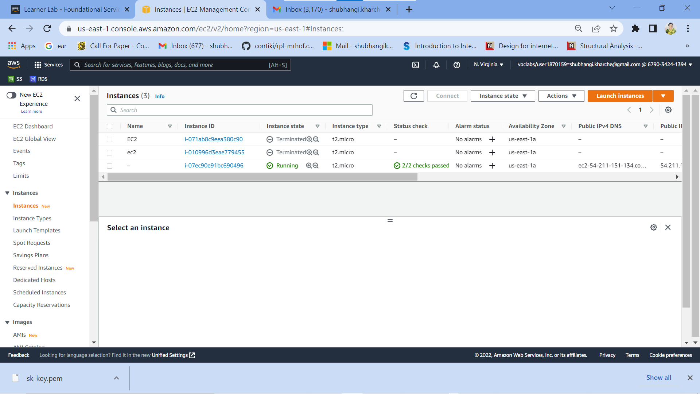

**Fig 5: List of EC2 instances after creation**

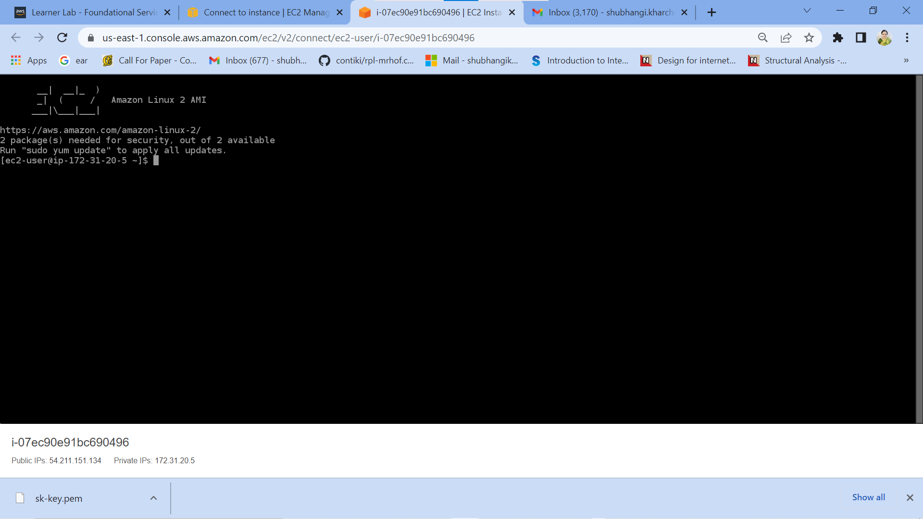

**Fig 5 (a): successful connection to EC2 instance (optional screenshot)**

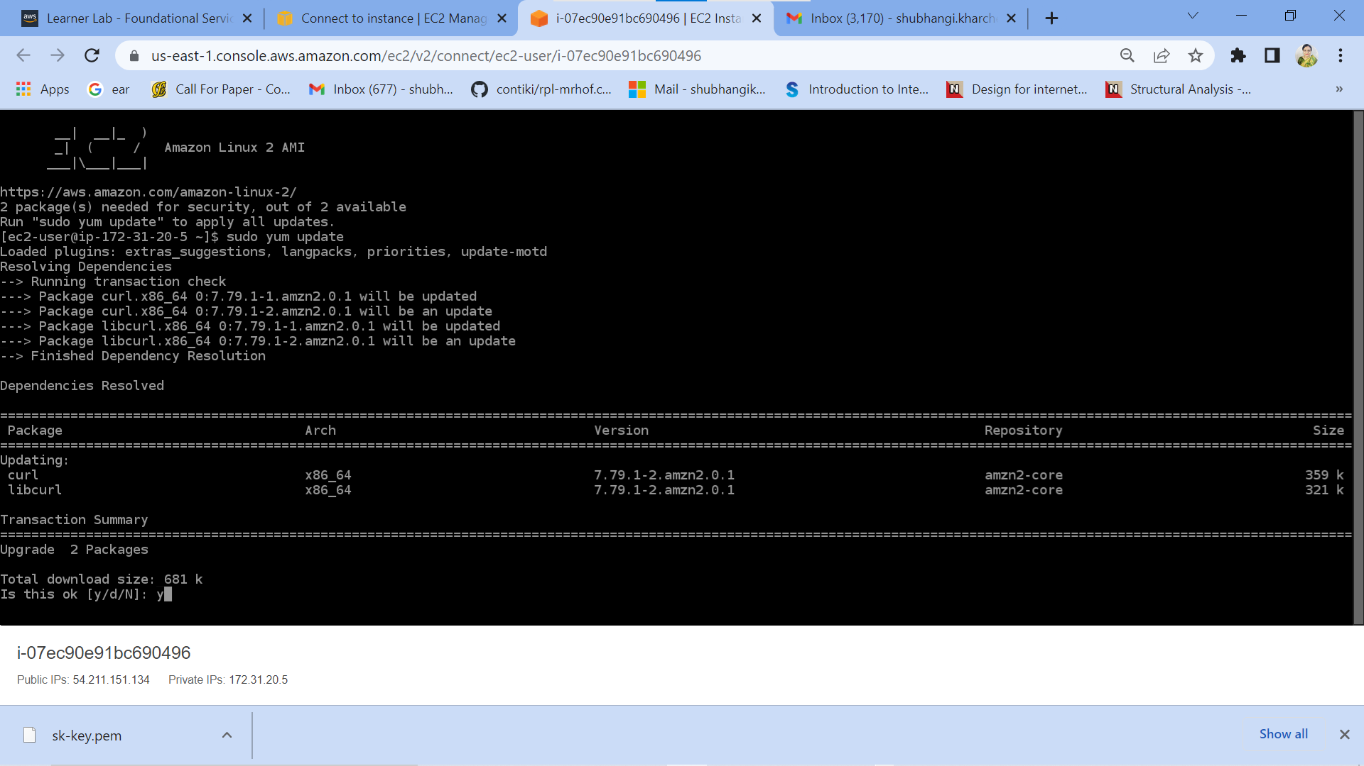

**Fig 5 (b): successful connection to EC2 instance (optional screenshot)**

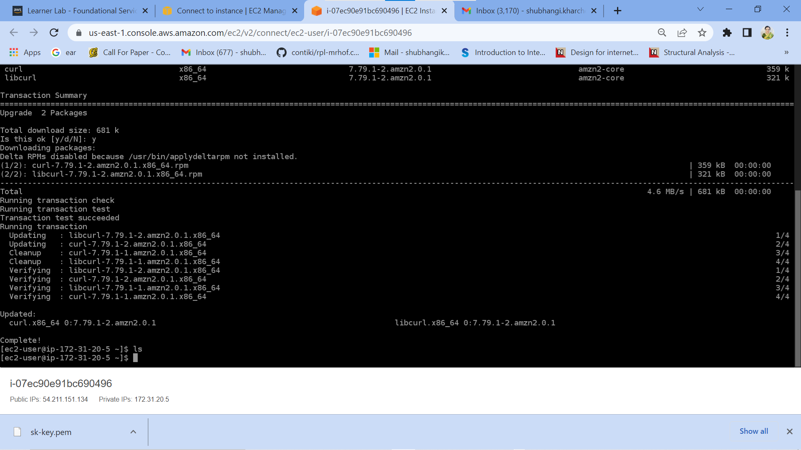

**Fig 5 (c): successful connection to EC2 instance (optional screenshot)**

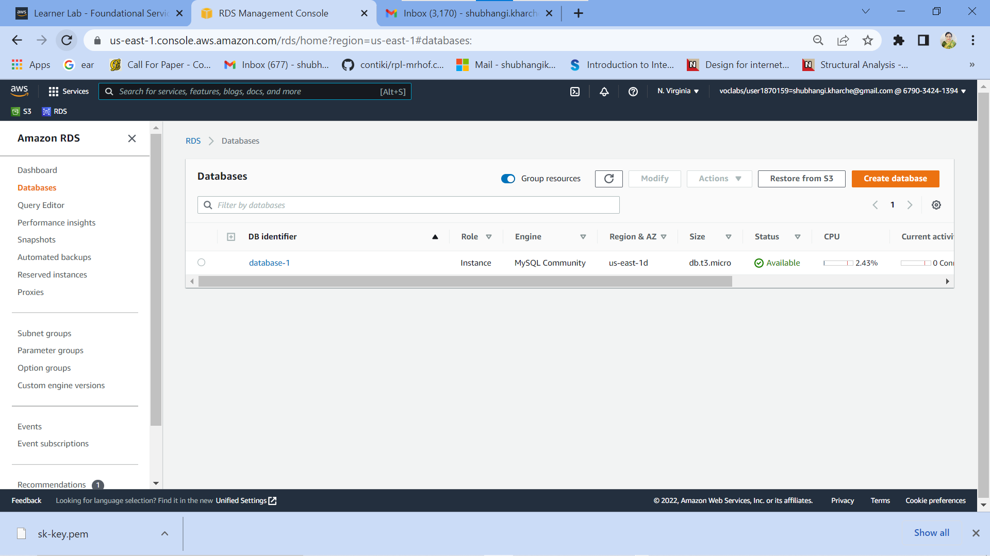

**Fig 6: List of RDS instances after creation**

|  |  |  |
| --- | --- | --- |
| Step number | b |  |
| Step name | Assignment of IAM role for EC2 instance |  |
| Instructions | 1) Navigate back to EC2- > Instances  2) Select the EC2 instance created in the previous step and select Actions-> Security -> Modify IAM role  3) Select the role LabInstanceProfile from the dropdown and click on Save |  |
| Expected screenshots | 1) Modify IAM role screen |  |

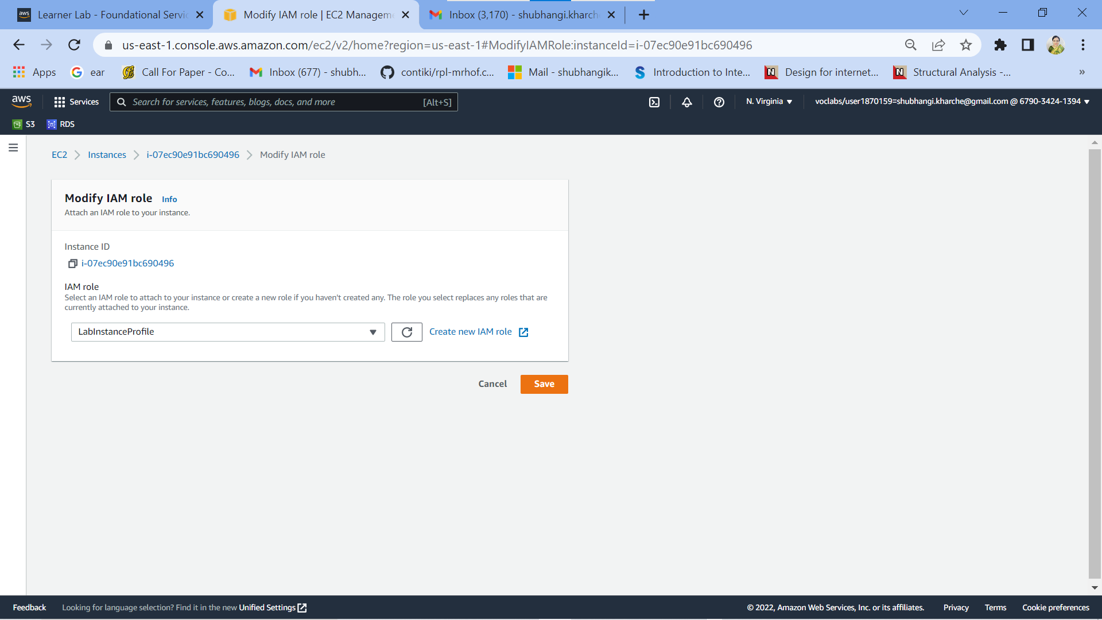

**Fig 7:** Modify IAM role screen

|  |  |  |  |  |
| --- | --- | --- | --- | --- |
| Step number | c |  |  |  |
| Step name | Configuration and Uploading of custom program |  |  |  |
| Instructions | 1) Download the file **docproc-new.zip** on your machine  2) Unzip the downloaded file  3) Enter the unzipped folder and open the file [views.py](http://views.py/) in the API folder using a text editor  4) In line number 19-24, modify the target bucket name to the one created in Step 2 (a) and modify the hostname, username, password and database variables to the values set while creating the RDS database and save the file  5) Copy the folder docproc-new to the home folder of the EC2 instance created in Step 3(a) using scp. Use the command given below  *scp -i <pem> -r ./docproc-new ec2-user@<ip>:/home/ec2-user* |  |  |  |
| Expected screenshots | 1) Modifying of the [views.py](http://views.py/) file to point to the target bucket | 2)Copying the folder to the EC2 instance |  |  |

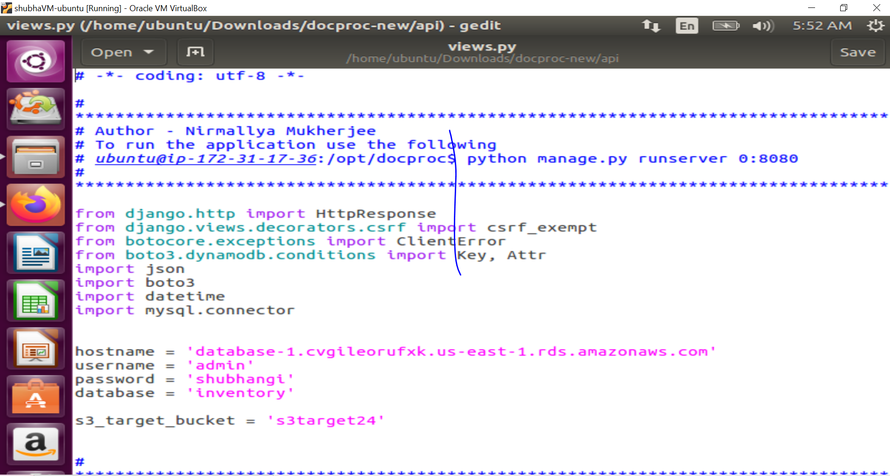

**Fig 8: Modifying of the** [**views.py**](http://views.py/) **file to point to the target bucket**

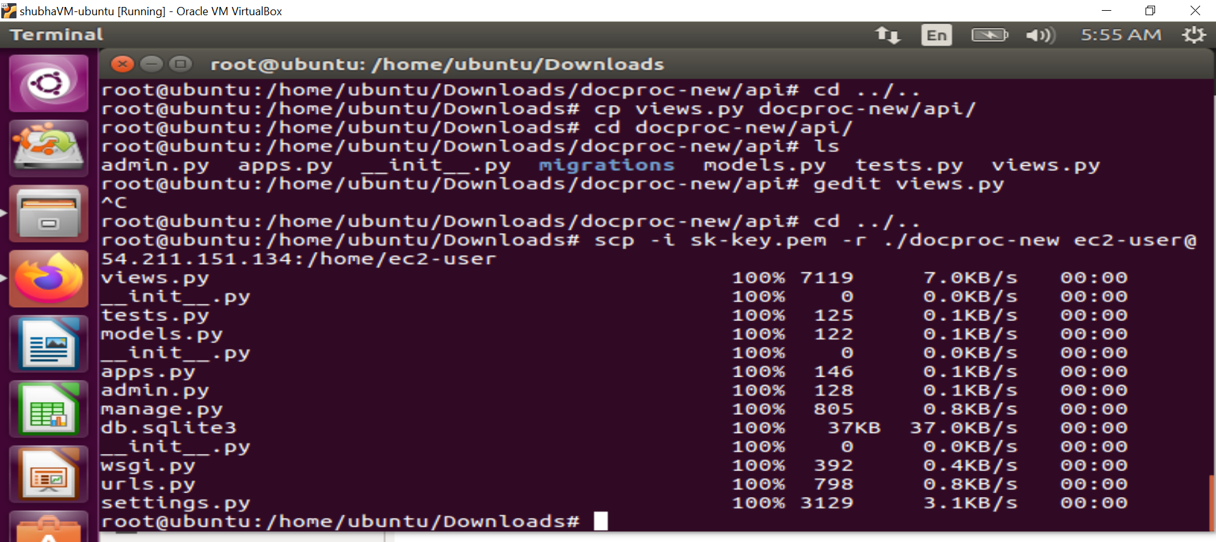

**Fig 9: Copying the folder to the EC2 instance**

Step 3: Creation and Verification of SNS subscription and Generation of CSV file

|  |  |  |  |  |
| --- | --- | --- | --- | --- |
| Step number | a |  |  |  |
| Step name | Starting the EC2 custom program |  |  |  |
| Instructions | 1) Log into the EC2 instance using SSH  2) Run the followng commands after successful SSH to start the server  sudo cp -r docproc-new /opt  sudo chown ec2-user:ec2-user -R /opt  cd /opt/docproc-new  sudo yum update  sudo yum install python-pip -y  python -m pip install --upgrade pip setuptools  sudo pip install virtualenv  virtualenv ~/.virtualenvs/djangodev  source ~/.virtualenvs/djangodev/bin/activate  pip install django  pip install boto3  pip install mysql-connector-python-rf  python manage.py runserver 0:8080  **Keep this terminal window open throughout the rest of the exercise** | | | |
| Expected screenshots | 1) Server in waiting state |  |  |  |

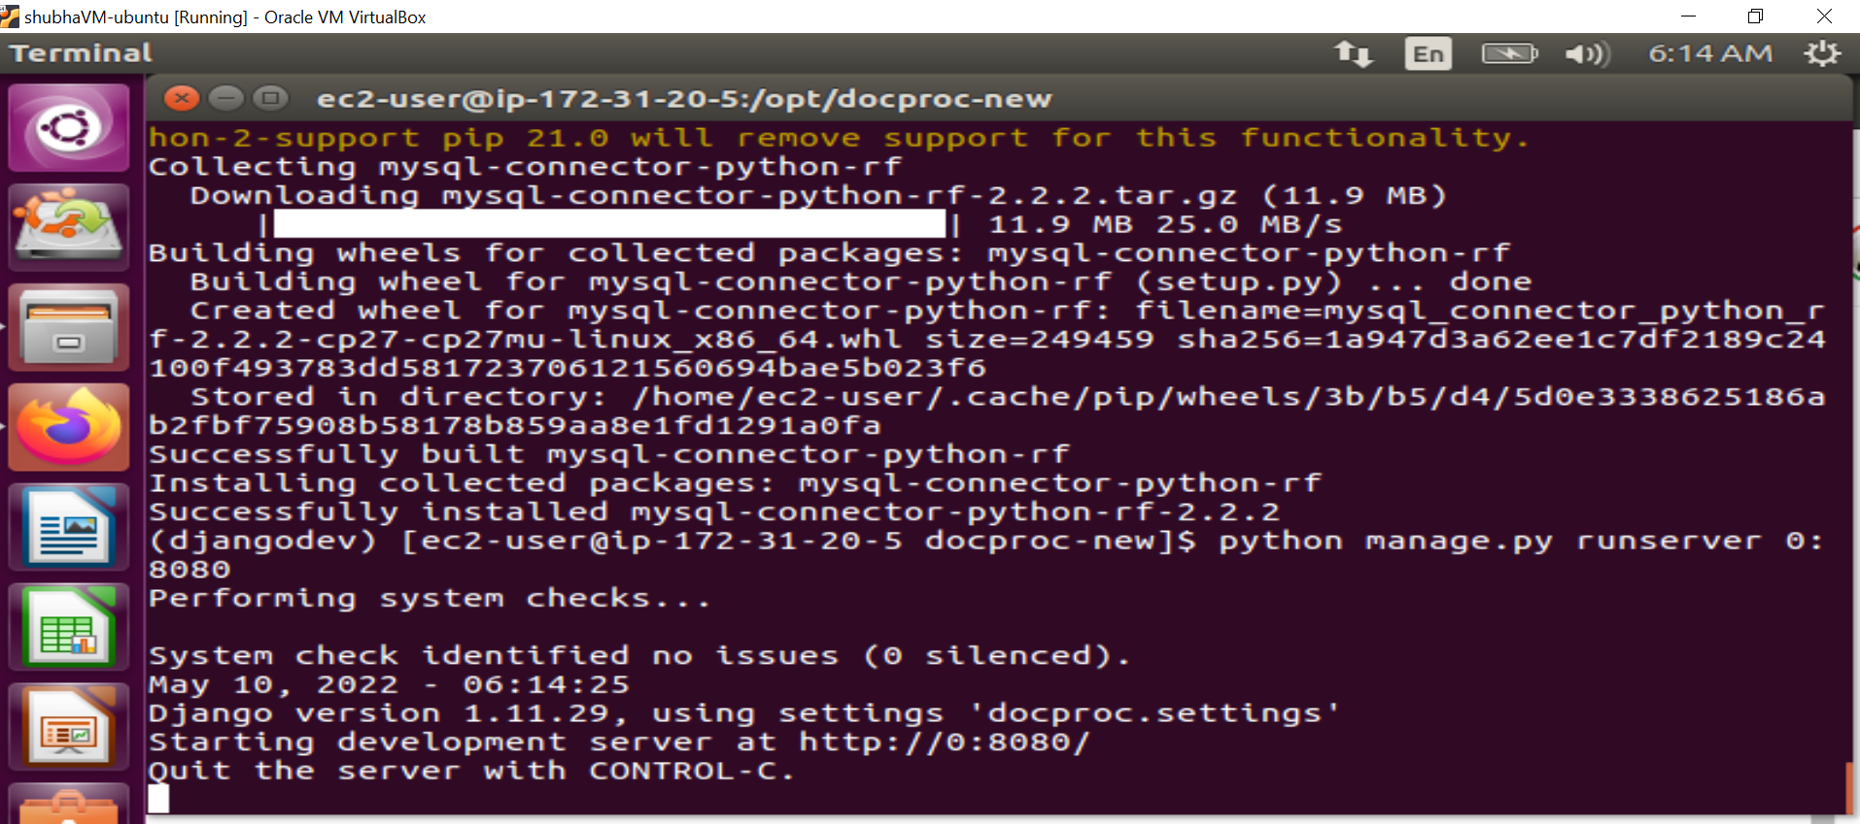

**Fig 10: Server in waiting state**

|  |  |  |  |  |
| --- | --- | --- | --- | --- |
| Step number | b |  |  |  |
| Step name | Creation of SNS subscription |  |  |  |
| Instructions | 1) Navigate to SNS in the AWS Console and select the topic S3ToEC2Topic  2) Click on Create Subscription  3) Enter the following details  Protocol : HTTP  Endpoint : http://<host>:8080/sns where <host> in the public IP of the EC2 instance  Click on Create Subscription  4) In the EC2 terminal window, look for the field "SubscribeURL" and copy the entire link given  **Note: If a message is seen "ValueError: No JSON object could be decoded", it can be safely ignored**  5) Paste that link into a browser window to verify the SNS subscription (Ignore any messages received in the web browser) | | | |
| Expected screenshots | 1) Subscription URL in EC2 terminal Window |  |  |  |

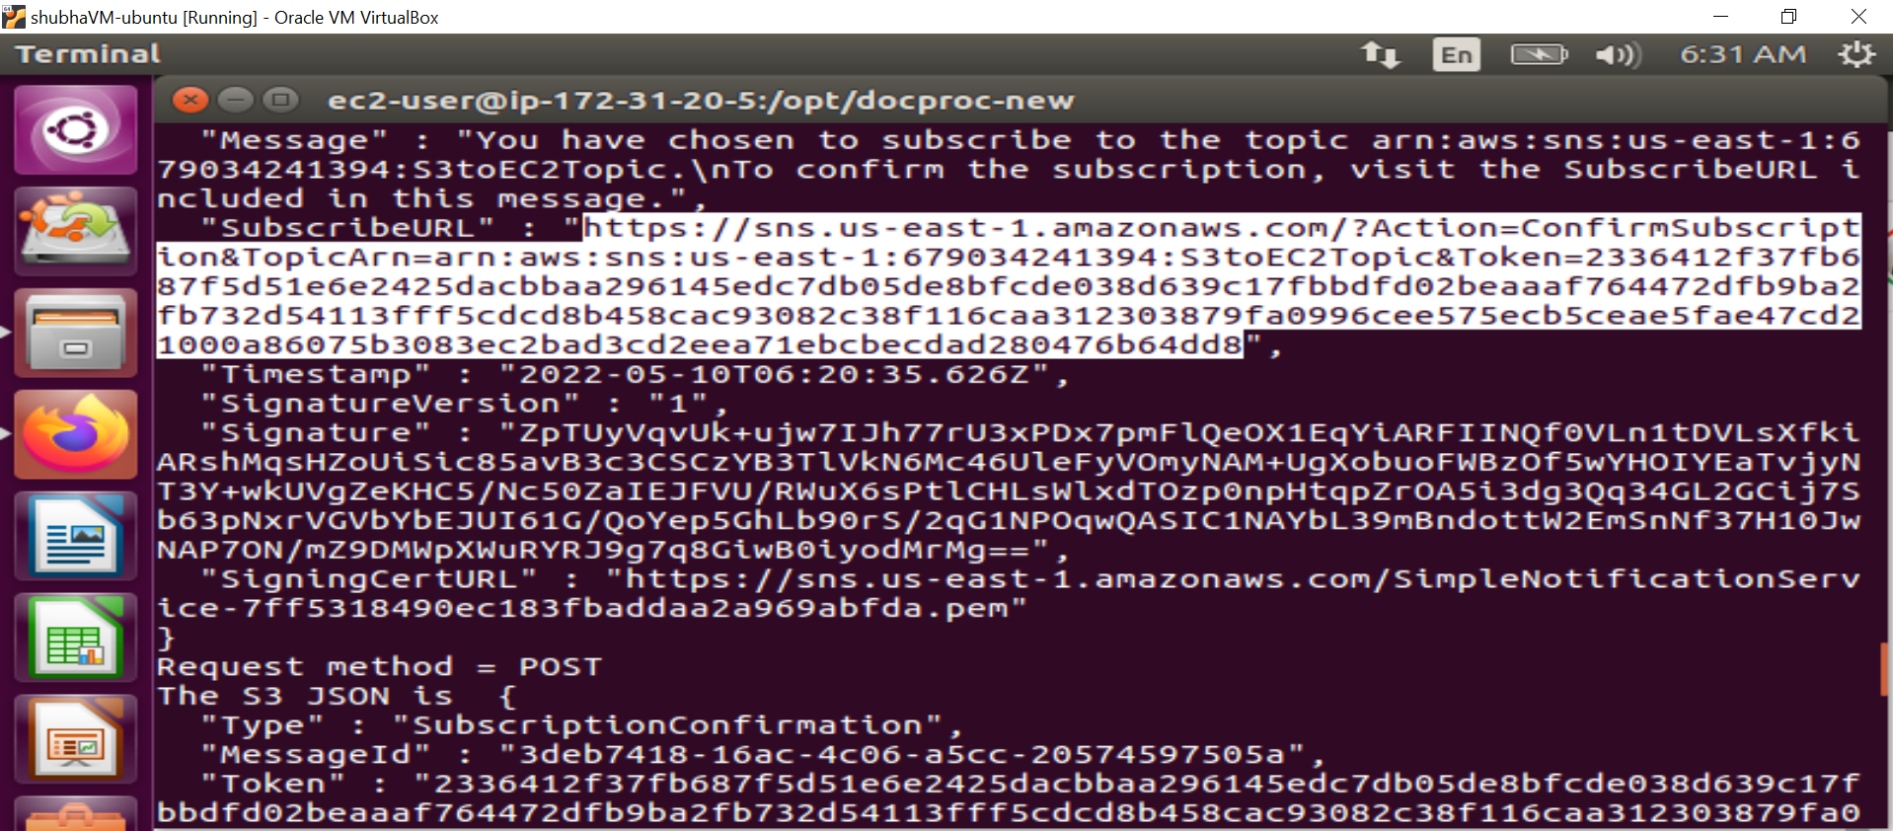

**Fig 11: Subscription URL in EC2 terminal Window**

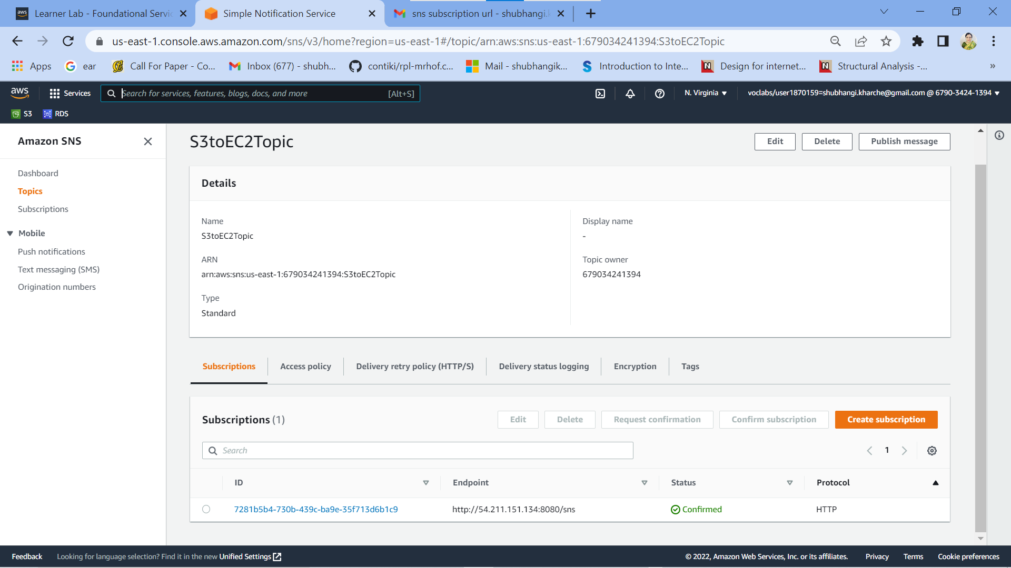

**Fig 11 (a): Subscription confirmed in sns (optional screenshot)**

|  |  |  |  |  |
| --- | --- | --- | --- | --- |
| Step number | c |  |  |  |
| Step name | Generation of CSV file |  |  |  |
| Instructions | 1) Download the file **docproc-invoice.txt** provided with this workbook  2) Navigate to S3 in the AWS Console  3) Upload the sample invoice file to the source S3 bucket using the default options  4) Verify that a CSV file is generated in the target S3 bucket. This may take a few minutes  5) (Optional) Login to the RDS instance using your preferred MySQL client and check the table created inside the specified database. | | | |
| Expected screenshots | 1) Generated CSV file in the target S3 bucket | |  |  |

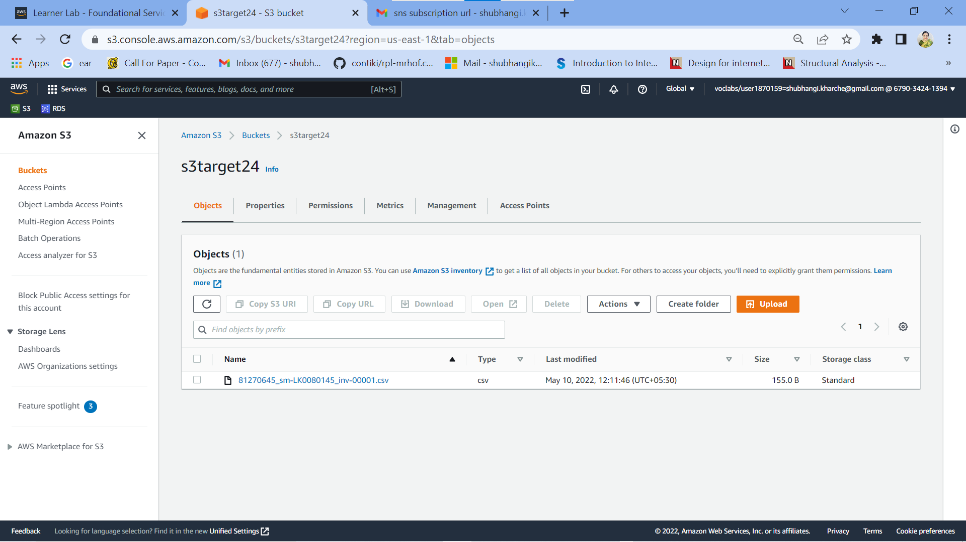

**Fig 12: Generated CSV file in the target S3 bucket**

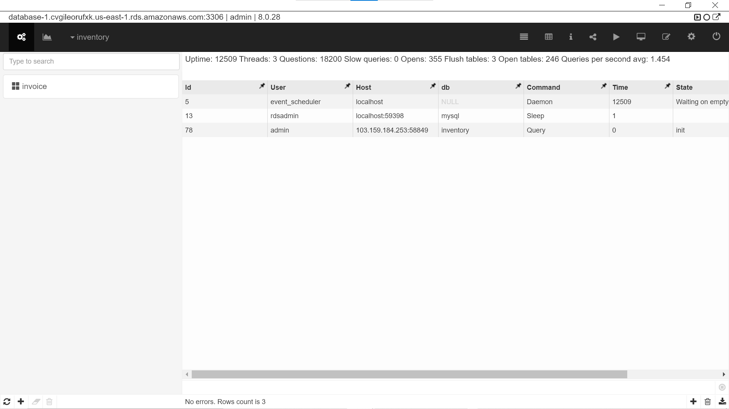

**Fig 12 (a): Table created in RDS database (optional screenshot)**

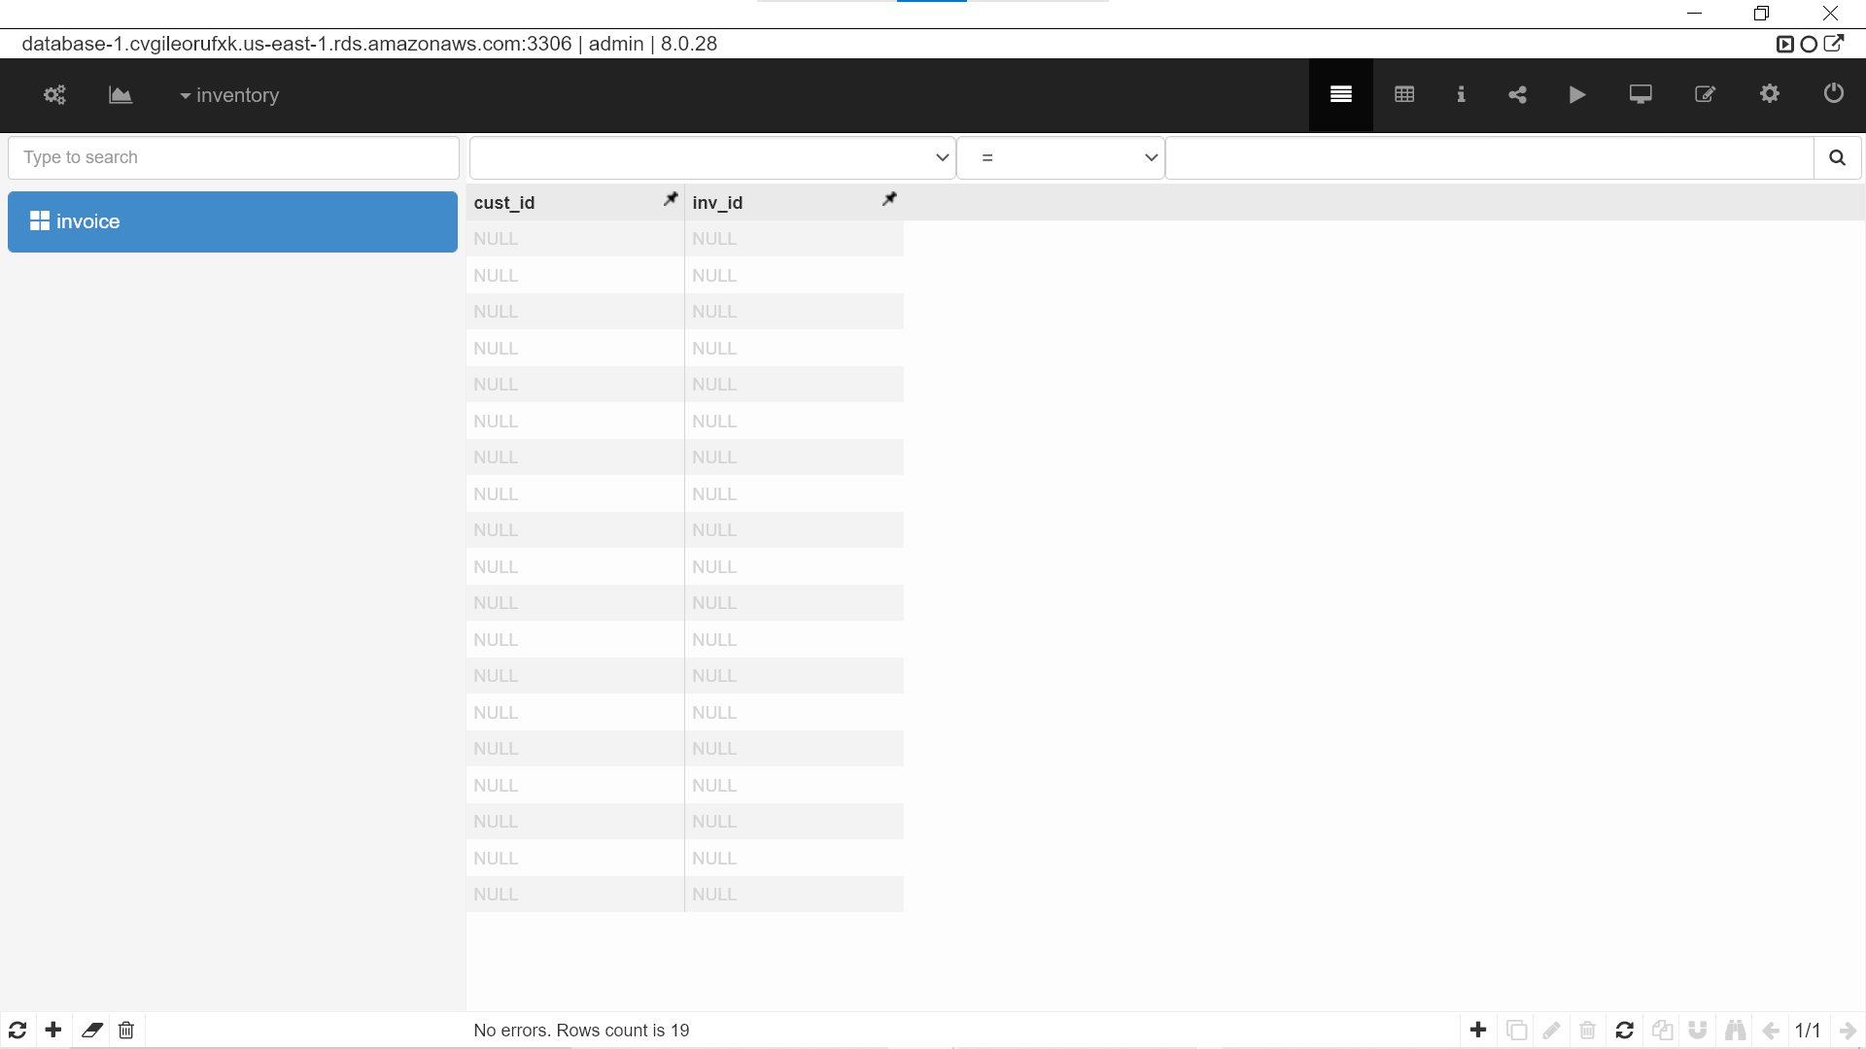

**Fig 12 (b): Invoice Table created in RDS database (optional screenshot)**

|  |  |  |  |  |
| --- | --- | --- | --- | --- |
| **Answer the following questions** | | | |  |
| Q1 | Which of the following properties of an AWS resource is sufficient and necessary to uniquely identify it across all of AWS? | | |  |
|  | a) ARN |  |  |  |
|  | b) Region and ARN |  |  |  |
|  | c) ARN and Account number |  |  |  |
|  | d) Depends on the resource used |  |  |  |
|  | Enter your answer here | ARN |  |  |
|  |  |  |  |  |
|  |  |  |  |  |
| Q2 | Which of the following step numbers in Step 1 allowed S3 to publish to the SNS topic created? | | |  |
|  | a) 1(a) |  |  |  |
|  | b) 1(c) |  |  |  |
|  | c) 1(d) |  |  |  |
|  | d) 1(b) |  |  |  |
|  | Enter your answer here | b) 1 (c) |  |  |
|  |  |  |  |  |
| Q3 | Which port is being used by SNS to send the notification to the custom program? | | |  |
|  | a) 8081 |  |  |  |
|  | b) 80 |  |  |  |
|  | c) 8080 |  |  |  |
|  | d) 8065 |  |  |  |
|  | Enter your answer here | c) 8080 |  |  |
|  |  |  |  |  |
| Q4 | How many IAM roles can be attached to an EC2 instance at a time? | | |  |
|  | a) 2 |  |  |  |
|  | b) 3 |  |  |  |
|  | c) 1 |  |  |  |
|  | d) Depends on the policies required |  |  |  |
|  | Enter your answer here | c) 1 |  |  |
|  |  |  |  |  |
|  |  |  |  |  |
| Q5 | As a product manager, how would you describe the benefits of this architecture to an client, as compared to an equivalent on-premises architecture? | | |  |
|  |  | | |  |
|  | Following are the benefits of the architecture to a client as compared to an equivalent on-premises architecture:  1) Cloud architecture provides fully managed services.  2) No overhead of maintaining storage, compute, database, MySQL, API, python scripts etc. on premises.  3) .txt can be uploaded from anywhere to source bucket and .csv can be accessed from anywhere from target bucket.  4) Message is placed in SNS topic in response to event triggered in source s3 bucket.  5) EC2 gets the message from s3 source bucket with the help of custom program that subscribes to the SNS topic.  6) The s3 source bucket content is read, converted to CSV with the help of API and RDS database.  7) CSV record is written in s3 target bucket as an object.  8) Steps 3 to 7 are fully managed; the client need not maintain any of the required services on premises.  9) The client will save on hosting and managing the infrastructure on premises. | | |  |
|  |  |
|  |  |
|  |  |
|  |  |
|  |  |
|  |  |
|  |  |  |  |  |
|  |  |  |  |  |
|  |  |  |  |  |